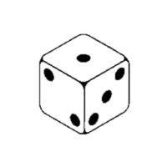**The Pig Dice Game**

**User Guide**

**Created by Sarah Ngo**

**How to Play:**

**This game is designed for a single player that gets five turns rolling a dice. The goal is to achieve a high score at the end of the five turns. In a turn, the dice may be rolled as many times as the player chooses. However, if a one is rolled the points for that turn are a zero and it’s on to the next turn. If you choose to end a turn, then the points for the turn are added to the total points for the game. Continue to play for a higher score.**

**Playing on the Nexys 4 Board:**

Not Used

Button Functions

Reset

Stop

Enter

PLAy

On the start of the game “Play” will be displayed. Pressing and holding the enter button will begin the rolling of the dice. By releasing the enter button, something similar to the following will be displayed.

S____13t2____5

Score of the turn current turn dice value

If the stop button is pressed on that turn, the score for that turn and the total points for the game will be displayed. If a roll of a one occurs then this will be displayed with a red LED light on. Otherwise a green LED light will be on. Pressing enter will begin the next turn and roll the dice.

S____13P____18

Score of the turn Total point value of the game

After five turns have been played, the total score for the game will display automatically. A blue LED light will indicate that the last roll was a one. A score of a zero will result in a bright white LED light. Otherwise a green LED light will be on.

SC0rE____29